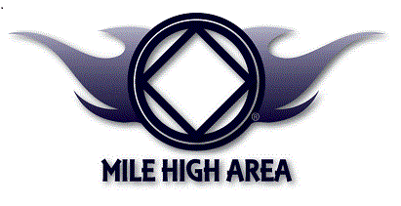
NARCOTICS ANONYMOUS

H & I Volunteer
Orientation and Training

Why:
We need NA Members to carry the NA Message to Addicts in Treatment Centers, Jails, and Prisons.

WHEN:
The 2ND Sunday of Even Months at 3:00 P.M.
August 8TH, October 10TH, December 12TH , February 13TH , April 10TH

WHERE:
1212 Mariposa (East of I-25 and South of Colfax)

Questions?
Lou S. 303-587-4248 or Jay Mc. 720-203-9205

